A neighborhood built to fail
NICAR/Cleveland, The Charlotte Observer, March 2007

How this story started. Previously, a 2005 series described the rise in high-interest mortgages and a 2006 series explored increasing foreclosures. This 2007 series focuses on one new starter home neighborhood to explore in detail how those who buy there meet financial disaster. Starter homes are defined as homes built since 1997 (when mortgage lending standards became less strict) and with current tax appraisal of less than $150,000. In our area, They are most often affected by concentrations of foreclosure.
Identifying foreclosures, starter homes, lenders
- Register of Deeds records. Deeds and deeds of trust show names of buyer, purchase date and price, lender and loan amount. Foreclosure filings also are available. Website provides images of documents. References to property sometimes are legal description or deed book & page, not address. But deed-page may be a unique ID that can be linked to other records.
- County property records. County property appraisers often flag foreclosures because they need to ignore them as benchmarks when estimating market values. ArcView shape files of parcels can be used to map parcels or parcel centroids.
- FHA data. FHA loans are a sample of sales for which additional info is available. Lender. Loan terms. Use of interest rate buydowns. Down payment gifts. Foreclosures.
- Building permits. Used to establish the universe of starter homes and assign subdivision names.
- Nexis. Aggregates public data on property. Search by address.
- Bankruptcy filings. Can provide list of debts. Bankruptcy can stop or prevent foreclosure.
- Records provided by homeowners. Including sales appraisals, purchase agreements, closing documents, mortgage applications.
- Consultant reports. A certified home inspector can document construction flaws. A certified appraiser can evaluate loan appraisals.

Factors in foreclosures
Foreclosures happen when a home buyer can’t make payments, and the home couldn’t be sold for enough to cover the mortgage. Are income and debts accurately listed on loan application? If payments are programmed to increase, is the buyer qualified for the higher payment? Is the purchase price increased to cover the cost of incentives like down payment assistance? Is the appraisal inflated? Does construction meet building standards?

Ted Mellnik tmellnik@charlotteobserver.com
Visualizing foreclosures
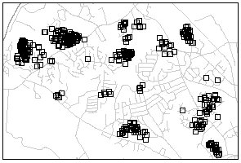Foreclosures can be shown as dots on a map (top right). You can geocode foreclosure addresses. Or you can or get coordinates for your dots from the centroids of parcels in an ArcView shape file.
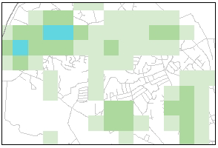The density of the dots can be summarized using the free software CrimeStat (orArcView’s Spatial Analyst extension).. The middle image at right, created with CrimeStat, shows foreclosures per square mile for cells in a grid.
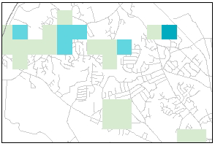For better context, the density of foreclosures can be combined with a density of homes to produce a foreclosure rate as a percentage of new homes (bottom right).
You can download CrimeStat at www.icpsr.umich.edu/CRIMESTAT/
The documentation is many hundreds of pages. Some hints: After installation (Chapter 1), review the quick guide (Chapter 2) for info on how to create your grid and load your point data, which much have coordinate fields. Then skip all the way to Chapter 8. It describes spatial modeling using kernel density interpolation. There are instructions and examples.
Note: There’s a way to summarize two dot layers and create a grid of the densities ratio in one operation. Don’t. Better to do two separate grids, then join them and calculate the ratio. That way you can filter out those troublesome small denominators.
If you’re doing a story
- Find out how your local foreclosure process works.
- Organize, so you don’t look up same info again. Organize, so you don’t look up same info again.
- Collect documents from as many homebuyers as you can.
- Check with regulators for complaints or sanctions against lenders, appraisers, builders, etc.

