Foreclosing on the American Dream
The Charlotte Observer, Jan. 15-18, 2006
http://www.charlotte.com/mld/charlotte/news/special_packages/foreclosure/
Reporters Lisa Hammersly Munn, Binyamin Appelbaum, Ted Mellnik

How this story started. Home loan failures in our home county quadrupled since 1999. A 2003 story found rapidly rising mortgage fraud, and a 2005 series described broad growth in high-interest mortgages – both linked to foreclosure.
What is foreclosure? A lender, who holds a mortgage or deed of trust, requires sale of real property to recover money due when the borrower fails to pay. Foreclosure is a process. The borrower often has a time to pay the amount due.
Identifying foreclosures
- Court records. Foreclosure filings were available from court records. Unfortunately, there was no compiled data available from the courts on foreclosures that went through the entire process. Register of deeds website provides images of documents. References to property usually are legal description or deed book & page, not address.
- County property records. County property appraisers are interested in foreclosures because they need to ignore them when setting market values for similar or nearby properties. Some sale records in the county property database were tagged as foreclosures.
To find other foreclosure saless, we looked at sales involving a trustee deed. This means a trustee, not the property owner, is selling. (Trustee deeds are used in Alaska, Arizona, California, Colorado, Georgia, Idaho, Illinois, Mississippi, Missouri, Montana, Texas, Virginia and West Virginia.) We selected trustee deed sales where a lender was involved.
- Vendor records. Information on foreclosures and property sales is compiled by data vendors like AutoTrack and DataQuick.
Factors in foreclosures
For details on the factors at work in foreclosures, we used LexisNexis, court and property records to compile detailed information on a 10 percent sample of foreclosures. Info available includes lender, loan amount, term, FHA or other government program, interest rates for high-rate loans, adjustable rates, deed type.
Based on our sample:
- 25% - FHA loans. Federal Housing Administration loans were the biggest factor driving local foreclosures. FHA is charged with promoting home ownership and strengthening communities. FHA foreclosures damaged communities the most because they tended to be concentrated & push down home values in newly built neighborhoods . That hurts all homeowners – including those who pay on time. This raises questions about FHA’s ability to prevent bad loans and to sanction lenders who make them.
- 24% - High rate lenders. Lenders say they charge high rates to those more likely to default. Critics say that can be a self-fulfilling prediction: High rates and fees cost thousands in additional interest payments, and often the interest rate escalates, driving costs even higher. Borrowers may have been qualified for only the initial rate. See our series on high rate lending at http://www.charlotte.com/mld/charlotte/business/special_packages/lending/
- 23% - Refinance loans. Loans that turn home equity into cash are popular. But some homeowners borrow more than they can afford. This most often involves older homeowners in older neighborhoods. They have a lot of equity, but may not have the income to keep up with debt repayment.
- 1% Mortgage fraud loans. For the basics of how mortgage fraud can work and who gets hurt, see the story at http://www.charlotte.com/mld/charlotte/news/special_packages/foreclosure/13620959.htm
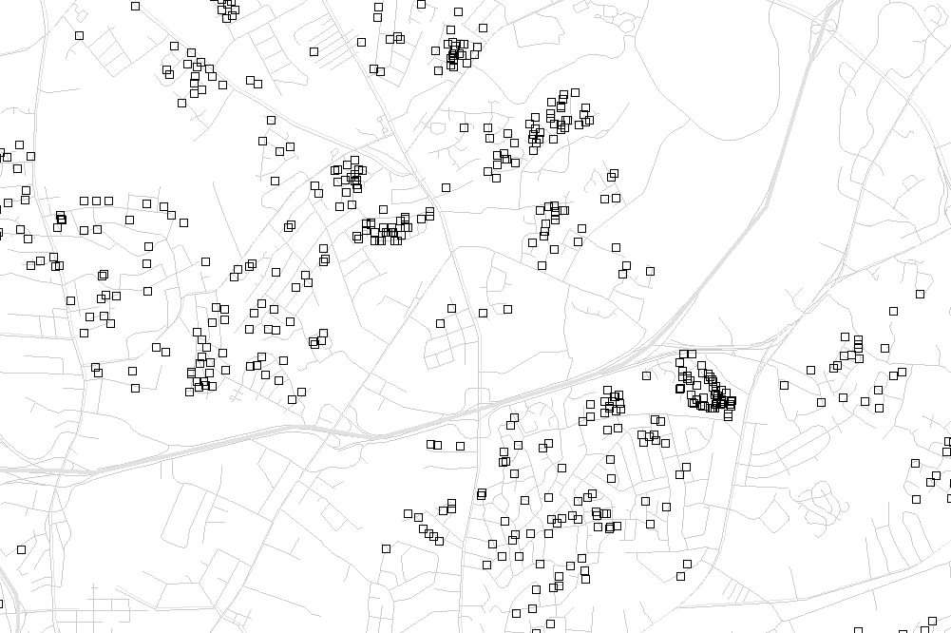
Visualizing foreclosures
Foreclosures can be shown as dots on a map. You can geocode foreclosure addresses. Or you can or get coordinates for your dots from the centroids of parcels in an ArcView shape file.
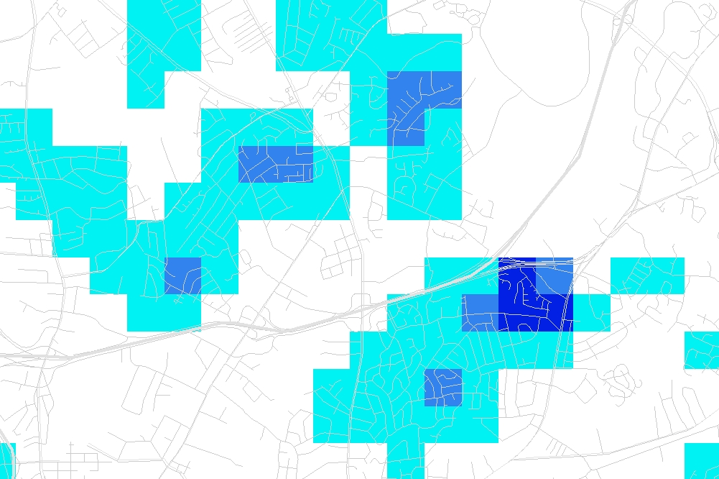
The density of the dots also can be summarized using ArcView’s Spatial Analyst extension or the software CrimeStat. The second image at right, created with CrimeStat, shows foreclosures per square mile for cells in a grid.
Maps can be a powerful reporting tool and a popular addition to stories. Neighborhood patterns aren’t readily apparent in lists, and everyone’s interested in issues that can impact the value of their home. We created interactive maps to help reporters and readers explore this info.
If you’re doing a story
Find out how your local foreclosure process works.
Organize, so you don’t look up same info again.
Appraisers. Mortgage brokers. There is little or nothing about their actions in public records. Check for complaints. Look closely at loan and closing documents from someone who bought & then lost a home.

